Sensors

Physical quantities like Humidity, temperature, pressure etc. are monitored to get information about the environmental conditions. Various sensors are being used to measure these quantities in analog form.

Sensor types

* Temperature
* Humidity
* Light
* Acceleration
* Force
* Frequency
* Flow
* Pressure
* Displacement

On Board Sensors

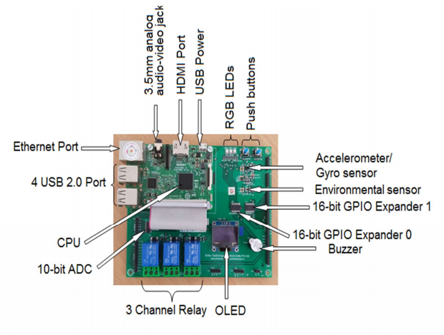

LED Sensors

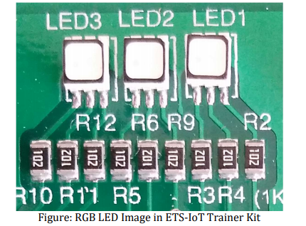

Push buttons

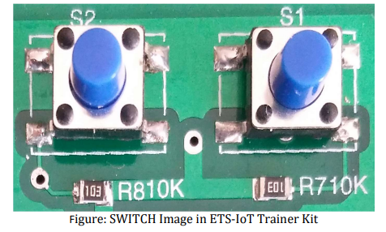

ENVIRONMENTAL Sensors

It will show the value of TEMPERATURE, PRESSURE and HUMIDITY. 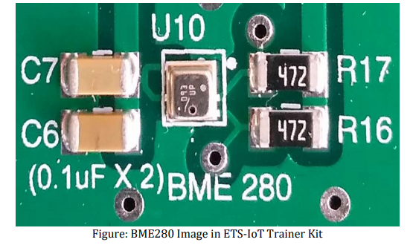

OFF BOARD SENSORS-PASSIVE INFRA RED:

A passive infrared sensor (PIR sensor) is an electronic sensor that measures infrared (IR) light radiating from objects in its field of view. They are most often used in PIR-based motion detectors.

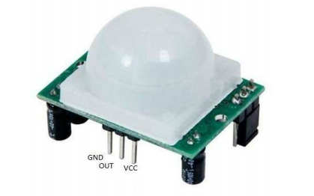

Applications of PIR Sensors

• All outdoor Lights

• Lift Lobby

• Multi Apartment Complexes

• Common staircases

• For Basement or Covered Parking Area

• Shopping Malls

• For garden lights

ULTRASONIC SENSOR:

Ultrasonic sensors “are based on the measurement of the properties of acoustic waves with frequencies above the human audible range”.

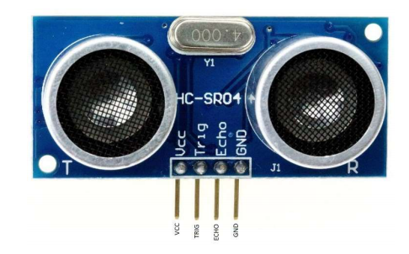

Applications of ULTROSONIC Sensors

• People detection for counting

• Vehicle detection for car wash and automotive assembly

• Robotic sensing

• Stacking height control

Examples

* Write a program to detect motion of a person and switch on LED1 in Red color.

Sensors used are PIR, LED

* Write a program to determine the distance to an object and if it comes within certain(5cm) range raise the alarm.

Sensors used are Ultrasonic sensor, Buzzer

* Write a program to read the temperature of the room and if exceeds 25 degrees run the fan fitted to servo motor.

Sensors used are BME280, Servo motor

* Write a program to capture pressure & humidity and upload data in to cloud

Sensors used are temperature sensor

SOIL MOISTURE SENSOR:

Soil Moisture Sensor is a simple breakout for measuring the moisture in soil and similar materials. 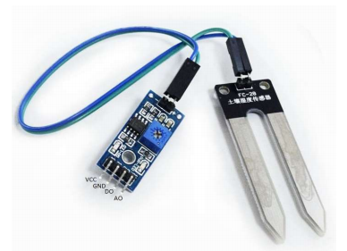

Applications of SOIL MOISTURE Sensors

• Agriculture

GAS SENSOR:

Gas Sensor module is useful for gas leakage detecting (in home and industry

Applications of GAS Sensors:

• Gas leakage detection

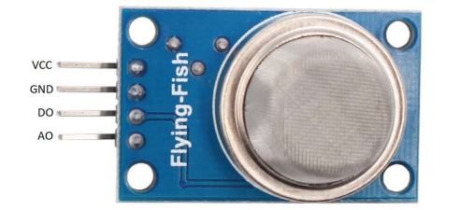

RAIN SENSOR:

The sensor plate has 2 PCB tracks which routed parallelly surrounding it.

These tracks are not connected, but when water/rain drop to the surface of plate and changes the resistance between the tracks because water/rain is conductive, this further changes the resistance between tracks and lower down the resistance. More water/rain touches the plate, resistance become lower.

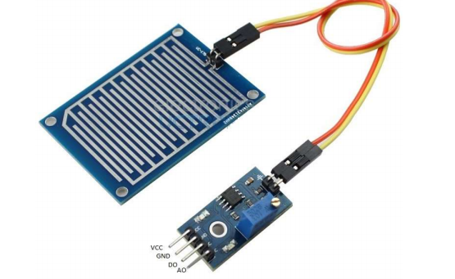

Applications of RAIN Sensor:

• Rain detection

AIR SENSOR:

It is a hazardous gas detection apparatus for the family, the environment, suitable for ammonia, aromatic compounds, sulphur, benzene vapour, smoke and other gases harmful gas detection, gas-sensitive element test. Air quality sensor is for detecting a wide range of gases, including NH3, NOx, alcohol, benzene, smoke and CO2. Ideal for use in office or factory with simple drive and monitoring circuit.

Applications of AIR Sensor:

• Domestic air pollution detector

• Industrial air pollution detector

• Portable air pollution detector

